Phoenix House
1a Cranbourne Road, Carlisle
CA2 7JN

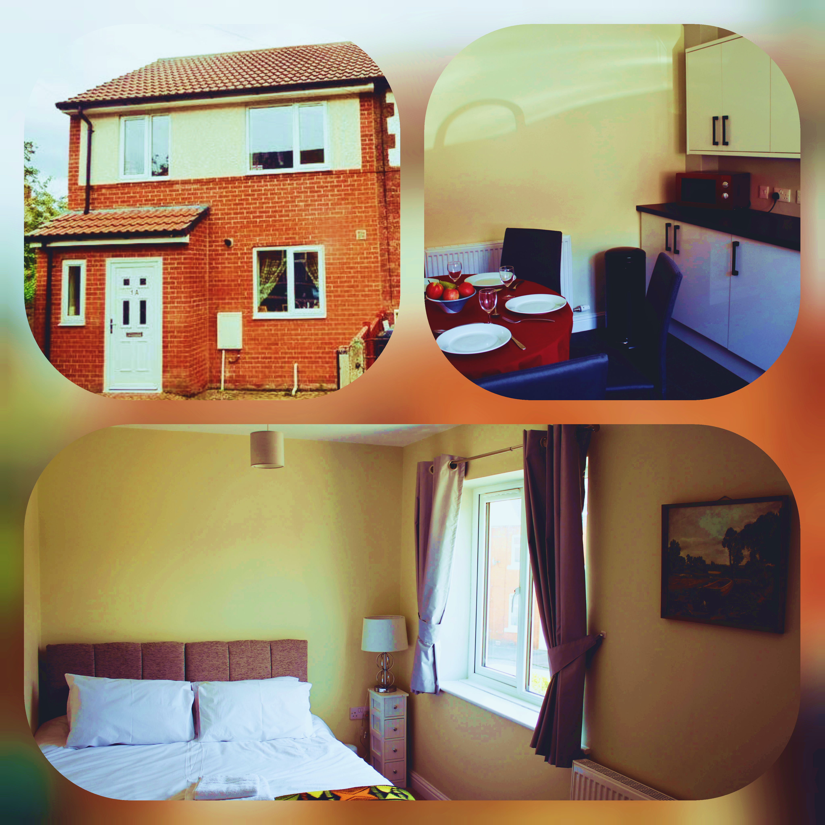

HOUSE MANUAL

Make yourself at home!
If you need assistance with anything, please contact:
Carvetii Accommodation Ltd
+44 7770 534 208
carvetii@yahoo.com

Welcome to our home!

Thank you. We are so glad you decided to stay at Phoenix House, and we hope you have a great time in Carlisle.

This book contains information about the house and area to help you enjoy your stay. You should find everything that you need, but if you have a question that is not covered in here, please do get in touch and let me know how we can help.

We hope you enjoy yourself and visit again in the future!

About Us

Carvetii Accommodation Ltd is a Serviced Accommodation enterprise with properties throughout Cumbria, the Forth Valley and in the Kingdom of Fife, Scotland.

This property is privately owned, and we expect all guests to enjoy the facilities and treat the property with the same respect that they would with their own house.

ABOUT OUR HOME

DESCRIPTION
The property is a relatively modern house that has been completely refurbished and redecorated. There are two good sized bedrooms, spacious lounge, kitchen, full bathroom, and toilet. The property can accommodate maximum of 8 people. It is situated close to the Carlisle Royal Infirmary. The city of Carlisle is well served with a superb range of local amenities and facilities including shops, hairdressers, supermarkets, sports facilities recreational playing fields and parks. Phoenix House is in an area which has excellent access to the city centre.

ARRIVAL/DEPARTURE.
Check-in time: from 6:00 p.m. on the day of arrival
Early check-in is based on availability. If guaranteed check-in for arrival prior to 6 p.m. is required, pre-arrangement and a payment will be required to cover the costs of cleaners reorganizing the schedules.
Check-out time: until 10:00 a.m. only on the day of departure.

TERMS AND CONDITIONS
Guests are encouraged to read carefully and are required to digitally sign the terms and conditions sent through email.

ROOM KEYS
On arrival - Keys are stored in lockboxes. Key safe code and other related information will be sent few hours before arrival to the email provided in the signed contract.

On departure – Please securely lock the door when leaving. Kindly place the keys back into the key safe as you have found it, set the numbers to 0000 and raise the cover plate again.

The cost for replacement of lost keys or damaged locks is applicable and a total amount of £10 for lost keys and £50 for lock replacement to be paid immediately.

DIRECTIONS
Phoenix House is in a residential area of North West Carlisle close to the Royal Infirmary and a ten-minute taxi ride from Carlisle Railway Station.

PARKING
There is an off-street parking facility fit for two vehicles (small to medium size). On street parking is also available. Do not leave any valuables inside your car while it is parked. We do not accept responsibility for the loss or theft of any such articles while your car is parked.

SMOKING
Smoking is strictly prohibited within the property. A charge of £100 will be applied.

PET POLICY
Pets are allowed provided that the pet owner agree to the following restrictions mentioned in the Terms and Conditions with an extra charge.

LOST & FOUND POLICY
Carvetii Accommodation assumes no liability for lost, misplaced, stolen, damaged valuables and belongings. If you discover that you have left behind something of value to you, please call us immediately and we will try to assist you in locating your lost item. Any item, except for perishable items, left behind by our guests and found after departure by Housekeeping will be collected, and kept in a secure location for collection by the owner for up to 10 days. Reasonable effort may be made to notify the guest that an item has found. Perishable items, underwear, and miscellaneous toiletries are discarded immediately.

WIFI/INTERNET
ID: TALKTAK3EBEAA
Password: MGRATGKU

APPLIANCES/FEATURES
During the stay, guests can use all the devices that are available in the house, following the instructions for proper usage. In case a devices malfunctions and the equipment breaks down within the accommodation unit, please inform the host immediately.

- The kitchen includes a refrigerator, freezer, microwave, cooker, oven, kettle, toaster and the cutleries and crockeries you might need

- There is washing machine and washing liquid and conditioner are provided.

- Complimentary tea/coffee

- Basic toiletries such as soap, shampoo, etc. and with enough towels of varying sizes.

- Convertible and comfortable beds

- There is a Smart TV for entertainment

BEKO DISHWASHER

Keys
On/Off/Programme Selection Key
When you use the On/Off/Programme Selection key to select a programme, the On Warning control light will become on, and it will go off when you switch to the Off position.
Start/Pause/Cancel key
It is used to startup, pause or cancel the selected program.

Preparing the machine
- Open the door of the dishwasher.
- Place the dishes in accordance with the instructions in the user manual.
- Make sure that the upper and lower impellers rotate freely.
- Put adequate amount of detergent into the detergent compartment.
- Check if the Salt and Rinse Aid indicators light and add salt/or rinse aid if needed.
- Close the door of the dishwasher.

When the machine does not start
Check if the power cable is plugged in.
Make sure that the water inlet tap is open.
Make sure that you have closed the door of the machine.
Make sure that you have turned on the machine by pressing the On / Off button.
Do not overload the baskets in excess of their capacity

Items not suitable for washing in the dishwasher
Never wash dishes soiled by cigarette ash, candle remnants, polish, dyestuff, chemicals, etc. in your dishwasher.
Do not wash silverware and cutlery with wooden or bone stems, glued pieces, or pieces that are not resistant to heat, as well as copper and tinplated containers in the dishwasher.
Decorated glasses and decorated lustre porcelains are not suitable for washing in the dishwasher. Manufacturers of some glassware and porcelain tableware items do not recommend washing such kitchen utensils in the dishwashers either.
Kitchen utensils that contains or are made of aluminum should not be washed in dishwasher.

INDESIT WASHING MACHINE

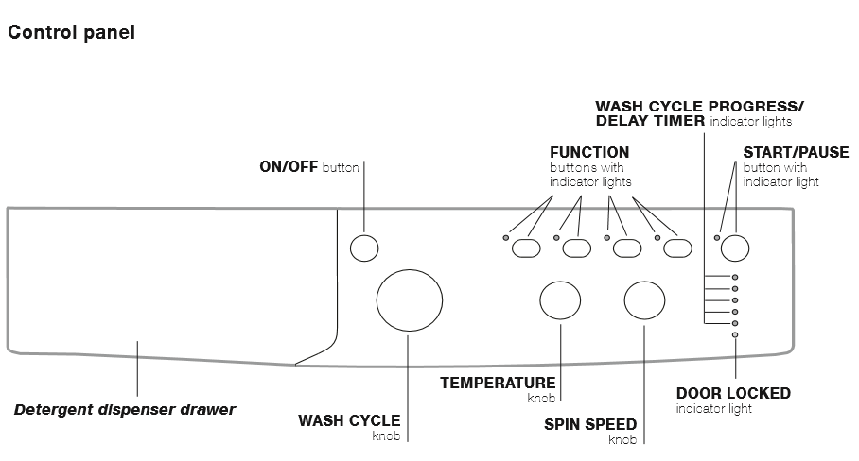

Starting a wash cycle
1. Switch the washing machine on by pressing the ON/OFF button. All indicator lights will switch on for a few seconds, then
they will switch off and the START/PAUSE indicator light will pulse.
2. Load the laundry and close the door.
3. Set the WASH CYCLE knob to the desired programme.
4. Set the washing temperature (see “Personalisation”).
5. Set the spin speed (see “Personalisation”).
6. Measure out the detergent and washing additives (see “Detergents and laundry”).
7. Select the desired functions.
8. Start the wash cycle by pressing the START/PAUSE button and the corresponding indicator light will remain lit in a fixed manner, in green. To cancel the set wash cycle, pause the machine by pressing the START/PAUSE button and select a new cycle.
9. At the end of the wash cycle the END indicator light will switch on. The door can be opened once the DOOR LOCK indicator light turns off (wait approximately 3 minutes). Take out your laundry and leave the appliance door ajar to make sure the
drum dries completely. Switch the washing machine off by pressing the ON/OFF button.
GUEST CONTACTS

We do not live at the property or nearby so you will be unlikely to meet us on arrival or during the stay. Please be aware that, in any case of emergency, you are responsible for managing your own evacuation and getting everyone involved to a safe place. By the time you arrive at the property, we encouraged you to take a good look at the property to be aware of emergency exits and ensure vulnerable guests are considered in your plans.

Please report any accidents or incidents in connection with any property damage.

HEATING USER GUIDE

Central Heating
Use arrows 'up' and 'down' to adjust the target temperature between 1.5 and 34.5

CH MODE
Press to cycle between:
- Off - The heating will be Off.
- Auto - The heating will follow the scheduled times.

BOOST CH
Press to bring the heating on for 60 minutes at 22°.

ADV CH
Press to 'skip' to the next scheduled temperature. Press again to cancel (Auto Only).

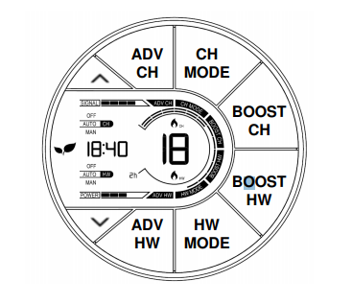

LOCAL TRANSPORTATION

Nearest Railway Station
The nearest railway station is Carlisle, approximately 1.1 miles away.
Address: Carlisle station, Court Square, Carlisle, Cumbria, CA1 1QZ

Stagecoach at Carlisle Bus Station
Lonsdale St, Carlisle CA1 1BJ
about 1.3 miles
26-31min walk

Airports
Carlisle Lake District Airport
Irvington, Carlisle CA6 4NW
about 7.6 miles
16-22min drive

Newcastle International Airport (the nearest major airport)
about 57.1 miles
1h 20min drive

HOSPITALS

Cumberland Infirmary
General Hospital
Newtown Rd, Carlisle CA2 7HY
+44 1228 523444

Brampton War Memorial Hospital
Tree Rd, Brampton CA8 1TX
+44 1228 608345

Wigton Hospital
Cross Lane, Wigton CA7 9DD
+44 16973 66600

CHURCHES

Newtown Methodist Church
185, 195 Newtown Rd, Carlisle CA2 7LW

St. Bedes
Catholic Church
120 Wigton Rd, Carlisle CA2 7ES, United Kingdom
Located in: George Hudson & Son – Funeral Directors Carlisle
+44 1228 521704

St. Barnabas
Brookside, Carlisle CA2 7JT

OTHERS

Newtown Post Office
109 Newtown Rd, Carlisle CA2 7JH
+44 1228 521057

Carlisle Ambulance Station
Salked Hall, Infirmary St, Carlisle CA2 7AN
+44 1228 596909

GROCERY

B&M Store
Discount store
Wigton Rd, Carlisle CA2 7EP
+44 3308 389039

Premier – Foreways
Convenience store
69 Wigton Rd, Carlisle CA2 7AY
+44 1228 529438

Sainsbury's Groceries Click & Collect
General store
Church St., Carlisle CA2 5TF
+44 1228 891350

Iceland Foods
Supermarket chain supplying frozen packaged foods, often discounted, plus some dry groceries.
70-78 Lowther St., Carlisle CA3 8DP
01228 819919

One Stop Community Stores Ltd
225-227 Newtown Rd, Carlisle CA2 7LN
+441228523701

SPAR Newtown Road (Convenience Store)
63-67 Newtown Rd, Carlisle CA2 7JB
+441228529754

LOCAL ACTIVITIES
WHERE TO GO

Carlisle Castle
Castle Way, Carlisle CA3 8UR
about 1.4km
4min drive

Cumbria’s Museum of Military Life
Alma Block, The Castle, Carlisle
CA3 8UR
about 1.0 mile
5 min drive

Carlisle Cathedral
7 Abbey St, Carlisle CA3 8TZ
about 1.6 miles
7-9min drive

Tullie House Museum And Art Gallery
Castle St, Carlisle CA3 8TP
about 1.4 miles
5 min drive

Guildhall Museum
Fisher St, Carlisle CA3 8JE
about 1.6 miles
7-9min drive

Dixons Chimney
B5299, Carlisle CA2 5UD
about 1.0 mile
5min drive

Rickerby Park
Carlisle CA3 9AD
about 2.1 miles
7min drive

The Citadel
91 English St, Carlisle CA3 8LU
about 1.9 miles
7-9min drive

Irish Gate Bridge
Castle Way, Carlisle CA3 8BB
about 1.6 miles
6min drive

A World in Miniature Museum
Houghton Hall Garden Centre CA6 4JB
about 5.4 miles
12-15min drive

Watchtree Nature Reserve
Nr Wiggonby, Carlisle CA5 6NL
about 6.7-8.0 miles
14-15min drive

Solway Aviation Museum
Aviation House, Carlisle Airport, Crosby on Eden CA6 4NW
about 8.2 miles
16-23min drive

PLEASE WRITE US A REVIEW.
We would love to hear your feedback!
We wish you a pleasant stay!

